35.53: a) There is a half-cycle phase change at the glass, so for constructive interference:
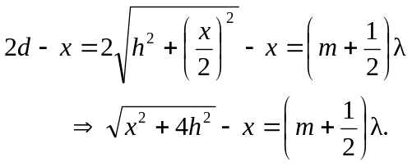
Similarly for destructive interference:
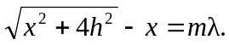

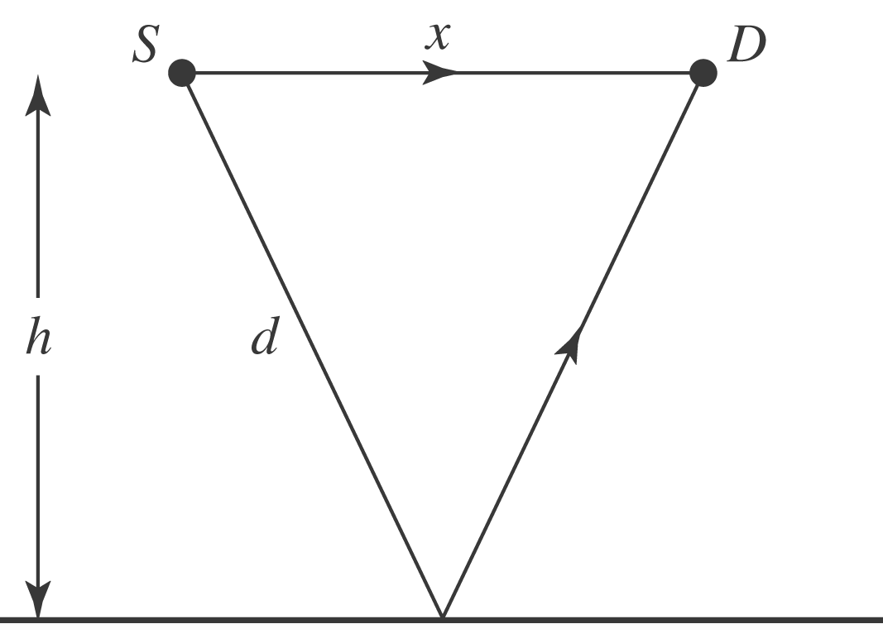

b) The longest wavelength for constructive interference is when 